sitemap
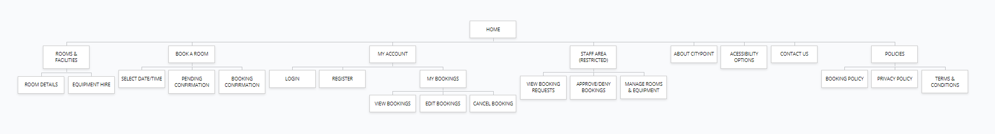

flowchart key identifiers

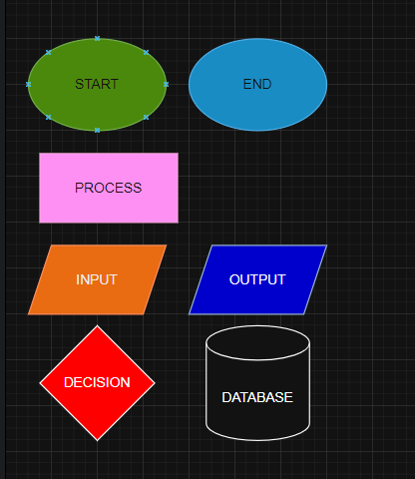

UsER LOGIN FLOWCHART
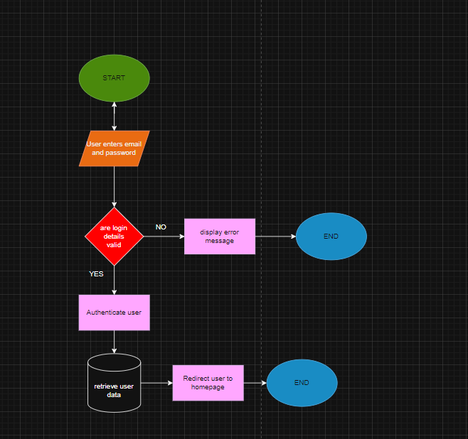

This flowchart represents the authentication process for users attempting to access their accounts. The system begins by collecting the user’s login credentials and validating them against stored account data. If the credentials are incorrect, the system displays an error message and terminates the process to prevent unauthorised access. If the credentials are valid, the system authenticates the user, retrieves their account data from the database, and redirects them to the homepage. This process ensures secure access control, protects user data, and restricts system features to authorised users only.

USER REGISTRATION FLOWCHART
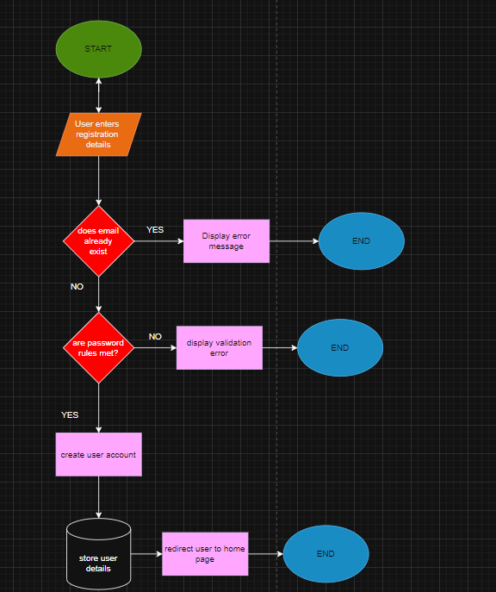
This flowchart describes the process of creating a new user account within the system. The user enters their registration details, which are validated to ensure the email does not already exist and that password rules are met. If any validation fails, the system provides feedback and terminates the process. If validation is successful, a new user account is created, user data is securely stored in the database, and the user is redirected to the homepage. This process ensures secure account creation, prevents duplicate accounts, and supports secure data management.

ROOM BOOKING FLOWCHART
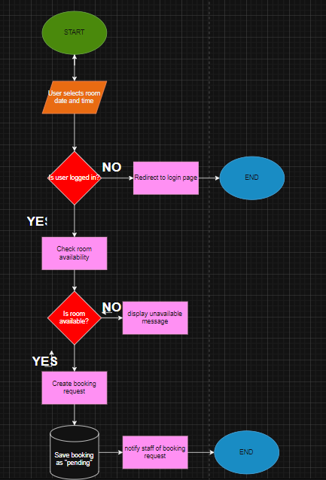
This flowchart models the process of requesting a room booking. The user selects a room, date, and time, after which the system checks whether the user is logged in to ensure only authenticated users can submit bookings. The system then validates room availability to prevent booking conflicts. If the room is unavailable, the user is informed and the process ends. If the room is available, a booking request is created and stored in the database with a “Pending” status, and staff are notified. This ensures controlled booking management, prevents double bookings, and enforces staff approval before confirmation.

STAFF BOOKING APPROVAL FLOWCHART
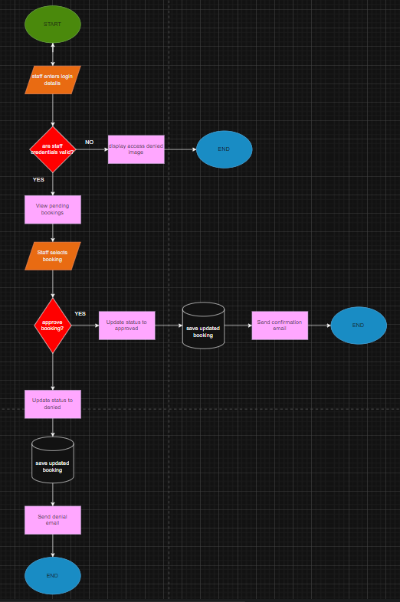
This flowchart represents the staff-side booking management process. Staff members authenticate into the system and access pending booking requests. After selecting a booking, the staff member decides whether to approve or deny the request. The system then updates the booking status accordingly in the database and sends a notification to the customer. This process ensures that all bookings are reviewed and authorised by staff, maintaining operational control, preventing unauthorised bookings, and enforcing business policies.
mANAGE EXISTING BOOKING FLOWCHART
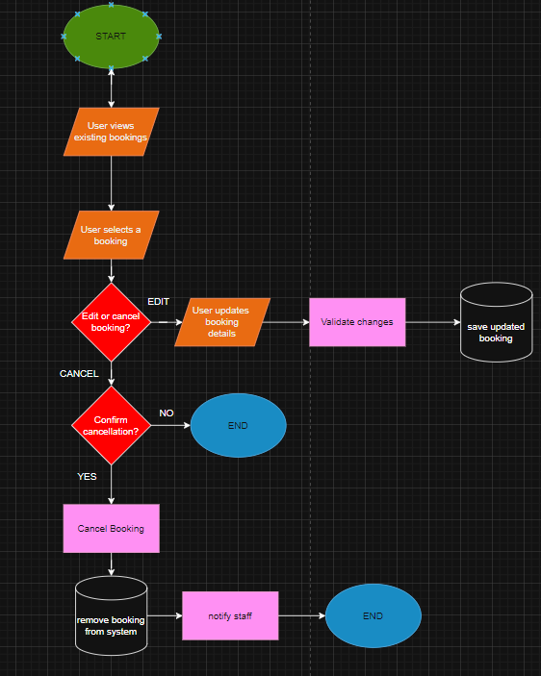
This flowchart shows how customers manage their existing bookings. Users view their bookings and select one to either edit or cancel. If the user chooses to edit the booking, the system validates the changes and updates the database. If the user chooses to cancel, the system confirms the action before removing the booking and notifying staff. This process allows users to manage bookings independently while maintaining system accuracy and data integrity, reducing staff workload and improving user experience.
Database design
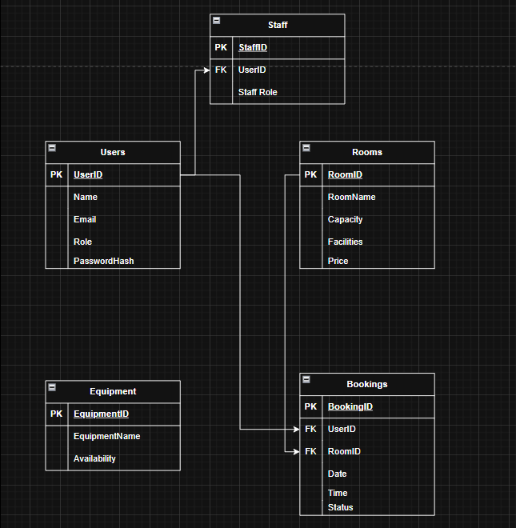
The database design provides a structured and efficient way to store and manage data required by the CityPoint Room Hire system. Separate tables are used for users, rooms, equipment, bookings, and staff to ensure data is organised and free from unnecessary duplication. Primary keys are used to uniquely identify each record, while foreign keys create relationships between tables, such as linking bookings to specific users and rooms. This relational structure supports key system functionality including account management, room availability checks, and booking approvals. Storing booking statuses within the bookings table allows the system to track whether requests are pending, approved, or denied, ensuring staff control over reservations. Overall, this design improves data integrity, security, and scalability while supporting efficient retrieval and updates of information across the system.

Staff
Column | Type | Required | Default | Validation | Primary/Foreign Key
StaffID | int | Yes |  | Must be a unique ID | Primary
UserID | String | Yes | Users ID | Must be a unique ID | Foreign
Staff Role | string | Yes

Users
Column | Type | Required | Default | Validation | Primary/Foreign Key
UserID | int | Yes |  | Must be a unique ID | Primary
Name | String | Yes
Email | string | Yes |  | Must include a valid structure, must have a “@” symbol, must have a domain name, must be in the correct format.
Role | String | Yes
PasswordHash | string | Yes

Rooms
Column | Type | Required | Default | Validation | Primary/Foreign Key
RoomID | int | Yes |  | Must be a unique ID | Primary
RoomName | String | Yes
Capacity | string | Yes
Facilities | String | Yes
Price | string | Yes

Equipment
Column | Type | Required | Default | Validation | Primary/Foreign Key
EquipmentID | int | Yes |  | Must be a unique ID | Primary
EquipmentName | String | Yes
Availability | bool | Yes

Bookings

Column | Type | Required | Default | Validation | Primary/Foreign Key
BookingID | int | Yes |  | Must be a unique ID | Primary
UserID | String | Yes | Users ID | Must be a unique ID | Foreign
RoomID | string | Yes | Rooms ID | Must be a unique ID | Foreign
Date | Date/Time | Yes
Time | Date/Time | Yes
Status | bool | Yes

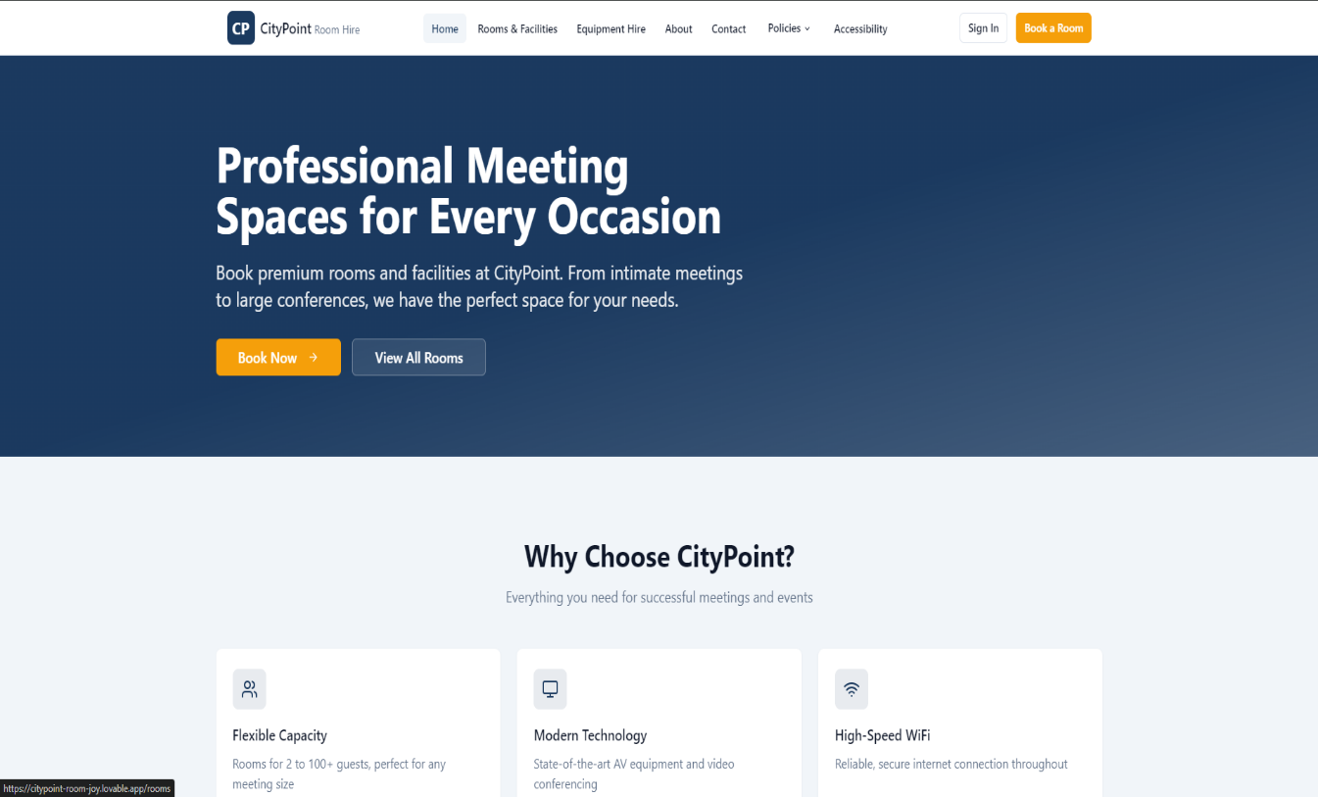
Navigation & Header:
The top left features the CityPoint Room Hire logo, establishing the business context for the user immediately.
The navigation bar includes links for “Rooms & Facilities,” “Equipment Hire,” “About,” and “Contact,” which directly addresses the requirement to provide customers with info on available rooms and facilities
A dedicated accessibility link in the header fulfils the clients request for features that support a wide range of users
The “Book a Room” button is highlighted in orange to provide a clear path for the functional requirement of booking rooms.
Hero Section:
Headline: Professional Meeting Spaces for Every Occasion” targets the clients primary audience: community groups and businesses.
Sub-headline: Mentions “intimate meetings to large conferences,” reflecting the flexible capacity (2 to 100+ guests) required by the brief.
Dual CTAs: “Book Now”: initiates the booking process for specific dates and times.
Why Choose CityPoint?
This section acts as a visual summary of the non-functional requirements and key facilities mentioned in the brief:
Flexible Capacity: Explicitly states the ability to handle various meeting sizes, from 2 to 100+ guests.
Modern Technology: Highlights “State of the art AV equipment and video conferencing,” satisfying the equipment hire requirement (projectors, speakers).
High-Speed WiFi: Addresses a critical non-functional requirement for a professional meeting venue.
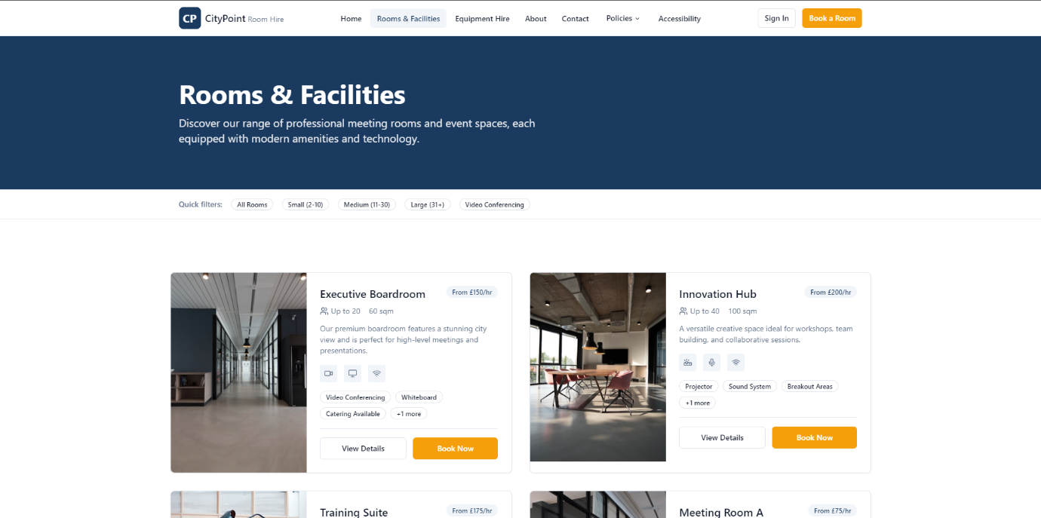

1. Filtering & Navigation System
- Active State Indicator: The "Rooms & Facilities" link in the header is highlighted, providing clear user feedback on their current location within the site hierarchy.

- Quick Filters Bar: This allows users to sort rooms by capacity ("Small," "Medium," "Large") and specific features like "Video Conferencing".

  - Rationale: This addresses the requirement for flexible capacity (ranging from 2 to 100+ guests) by allowing users to find a "perfect space for their needs" quickly.

- Functional Requirement: These filters represent a front-end interface for an algorithm that must query the room database based on user-selected parameters.

2. Room Information Cards
Each card acts as a data object representing a specific room. Key components include:
- High-Quality Imagery: Provides a visual representation of the professional meeting spaces.
- Capacity & Size Labels: Clearly lists "Up to 20" or "Up to 40" people and square footage, meeting the client’s need to provide specific room details.

- Dynamic Pricing: Displays hourly rates (e.g., "From £150/hr"), which is essential for business users and community groups to make informed decisions.

- Equipment Tags: Icons for WiFi, Projectors, and Video Conferencing highlight available equipment hire options.

3. Action Components (Call to Action)
- "View Details" Button: Leads to a dedicated page for that specific room, providing deeper information on policies and specific facilities.

- "Book Now" Button: This is the entry point for the booking process.

  - Logic Note: Clicking this would likely trigger a date/time picker, initiating a booking "pending confirmation" by staff.

4. Accessibility & Compliance
- Visual Hierarchy: Large headings and high-contrast buttons support accessibility features for a wide range of users.
- Iconography: The use of icons (e.g., camera for video conferencing, monitor for screens) helps users identify features without relying solely on text, adhering to industry-standard UI design.

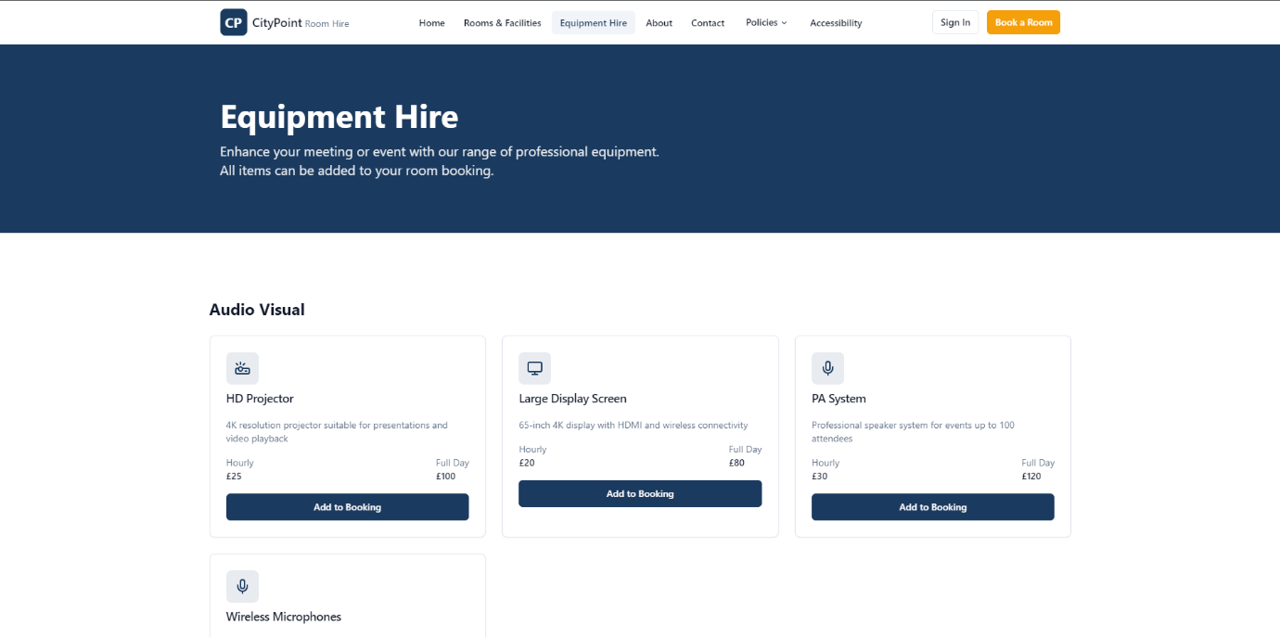

1. Itemized Selection
- Inventory Display: Shows specific hardware such as "HD Projectors," "PA Systems," and "Wireless Microphones".
- Tiered Pricing: Displays both "Hourly" and "Full Day" rates (e.g., £25/hr or £100/day for a projector), providing transparency for "short-term and day-long bookings".

- Technical Specs: Includes details like "4K resolution" and "wireless connectivity," ensuring professional users can verify the technology meets their needs.

2. User Integration
- "Add to Booking" Functionality: This button serves as a functional requirement to link equipment data with a specific room reservation.
- Bundling Logic: The text "All items can be added to your room booking" implies a backend relationship between the Equipment and Bookings database tables.
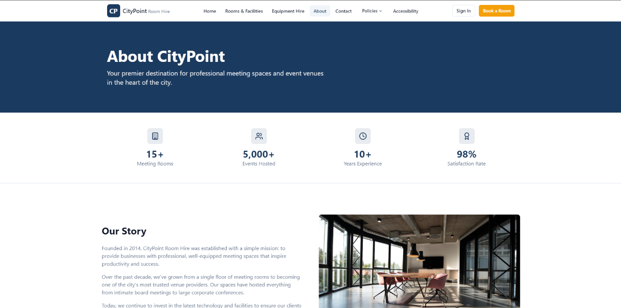

This page establishes the company’s authority and meets the requirement to provide staff and company details.
- Trust Metrics: Displays key performance indicators (KPIs) such as "15+ Meeting Rooms," "5,000+ Events Hosted," and a "98% Satisfaction Rate". These align with the KPI requirements for the proposal.
- Company Narrative: The "Our Story" section provides the business context required for the proposal. It explains the mission to support "productivity and success" for businesses and community groups.
- Operational History: Mentions the growth from a single floor to a trusted provider, which helps justify the solution to potential users by establishing brand reliability.
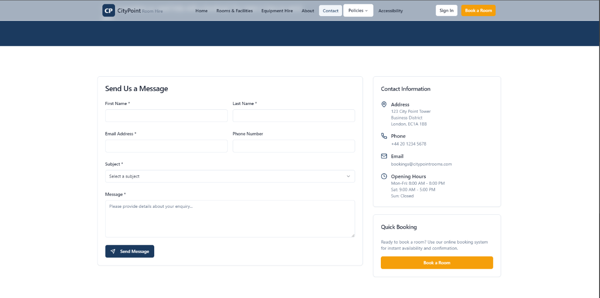
This page ensures that customers can reach the company and find location-specific details.
- Contact Form: Includes validation fields for "First Name," "Last Name," and "Email Address". This is part of the functional requirements for customer communication.
- Location & Accessibility: Provides the physical address and opening hours. This is essential for customers to identify if the venue meets their scheduling needs.
- Staff Interaction: The "Send Message" feature allows for pre-booking inquiries, which staff can manage in their staff area.
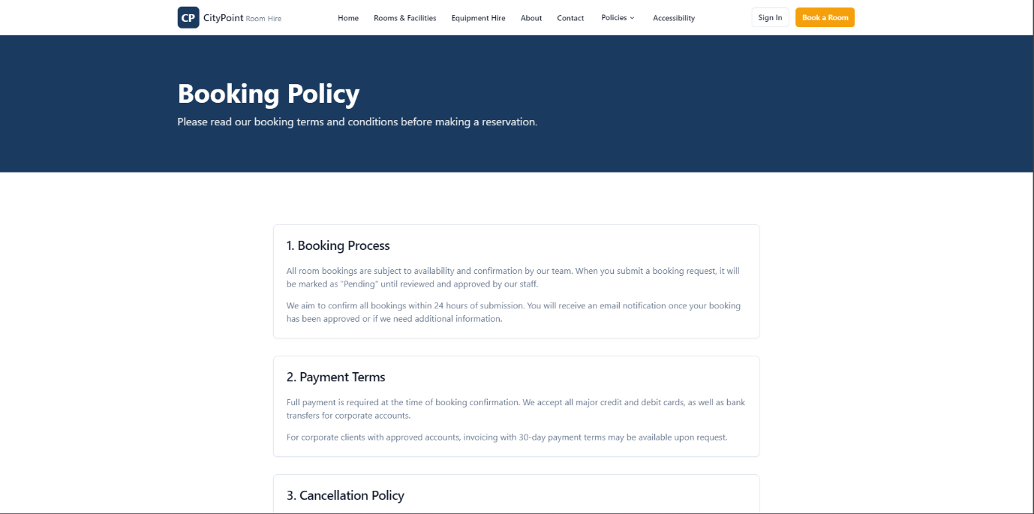

This page addresses the legal and regulatory guidelines required for the project.

- Section 1: Booking Process: Explicitly states that bookings are "Pending" until confirmed by staff. This manages expectations for the "pending confirmation" requirement.
- Section 2: Payment Terms: Details that full payment is required at confirmation and mentions invoicing for corporate accounts. This is a critical non-functional requirement for financial security.
- Section 3: Cancellation Policy: Provides a legal framework for the hire agreement, addressing regulatory guidelines.
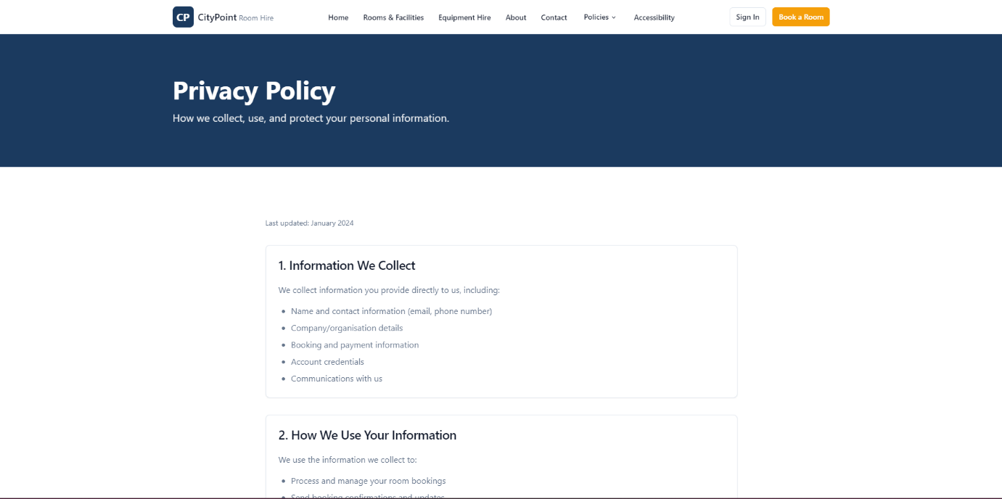
This interface is critical for addressing regulatory guidelines and legal requirements regarding data protection (e.g., GDPR).
- Data Minimization: Explicitly lists the categories of information collected, such as "Account credentials" and "Booking and payment information".
- User Transparency: Sections 1 and 2 detail how personal data is used specifically for managing bookings and communicating with users.
- Security Context: This page provides the rationale for the "Account Registration" feature, ensuring customers that their data accessibility is managed securely.

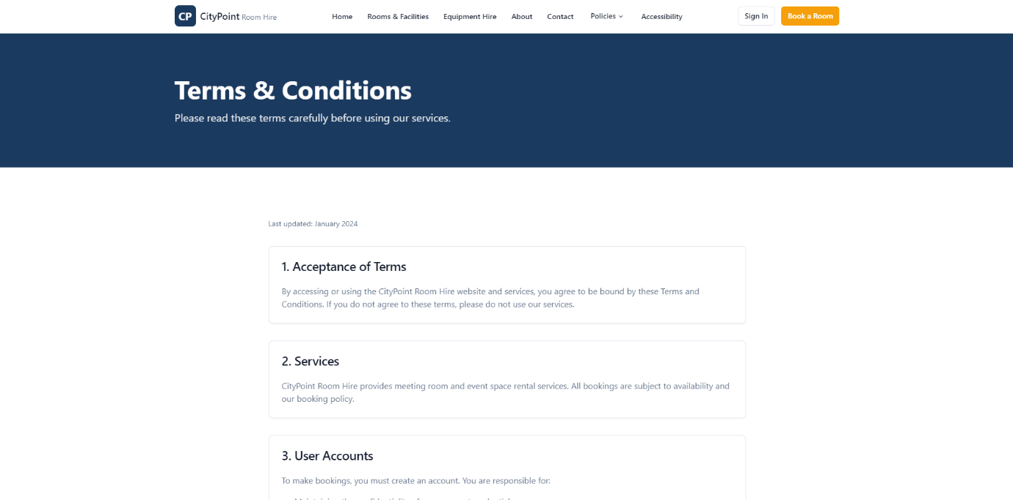
Terms & Conditions: Establishes the legal framework for "User Accounts," which is a suggested feature for managing existing bookings.

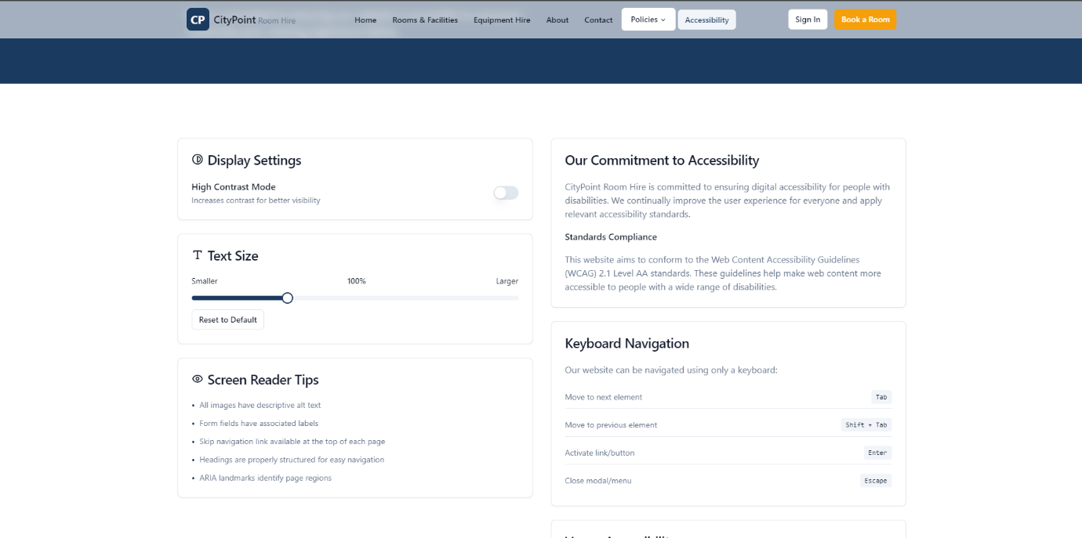
Display Settings:
- High Contrast Mode: A toggle switch that allows users to increase visual contrast. This is a non-functional requirement to support users with visual impairments or those in high-glare environments.
- Text Size Slider: A dynamic slider (0% to 100%+) that allows for manual font scaling. This provides a rationale for meeting accessibility standards without needing a separate mobile site.
Screen Reader Tips:
- Semantic Structure: This section confirms the use of descriptive alt text for images and ARIA landmarks. In your Activity B design documentation, this serves as evidence of following "industry-specific guidelines" like WCAG 2.1.
Standards Compliance & Commitment:
- WCAG 2.1 Level AA: The text explicitly states the solution aims to conform to Level AA standards. This is a critical Key Performance Indicator (KPI) for the proposal.
Keyboard Navigation (Input Mapping):
- Instructional Grid: Details specific key mappings (e.g., Tab to move to next element, enter to activate).
- Technical Rationale: This is essential for users who cannot use a mouse, directly addressing the "wide range of users" mentioned in the brief.

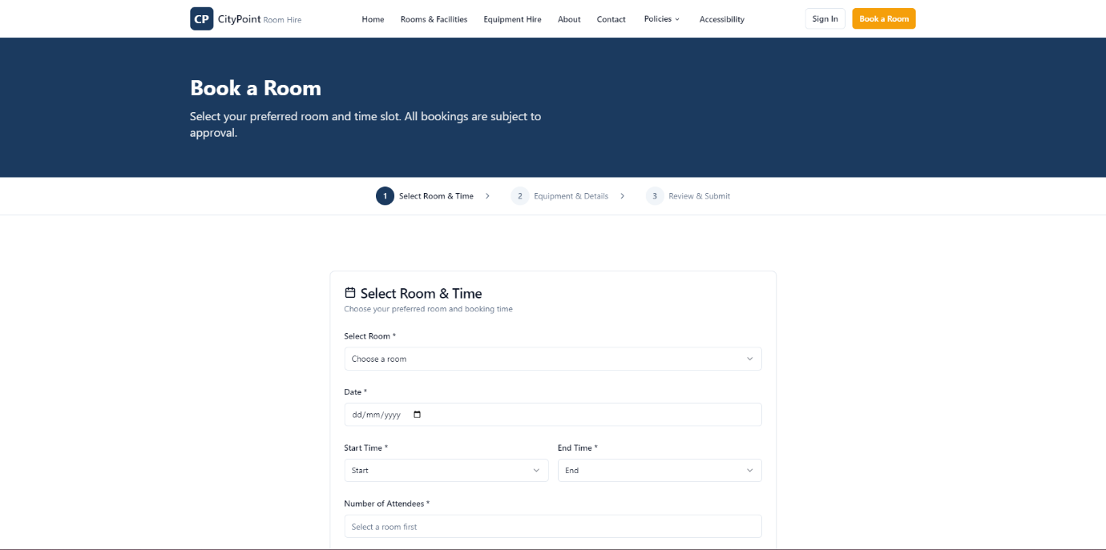
To fulfill the design documentation requirements for Activity B, here is the detailed annotation of the Book a Room page. These annotations connect the interface elements to the functional requirements and technical scope defined in the CityPoint Room Hire brief.

Wireframe Annotation: Book a Room (Step 1)
- Process Progress Indicator:
  - Visual Design: A three-step breadcrumb trail ("1. Select Room & Time", "2. Equipment & Details", "3. Review & Submit").
  - Rationale: This decomposes the complex booking problem into manageable stages for the user. It ensures that the requirement to "allow customers to book rooms for specific dates and times" is handled through a logical workflow.
- Dynamic Room Selection:
  - Dropdown Menu ("Select Room"): Facilitates the selection of specific rooms available for hire.
  - Technical Requirement: This input will trigger a backend query to verify real-time availability for the chosen room, ensuring the solution is robust and functional.
- Temporal Inputs (Date and Time):
  - Date Picker & Start/End Time Selectors: Allow users to specify the precise duration of their hire.
  - Business Context: Supports both "short-term and day-long bookings" for community groups and businesses.
- Attendee Validation:
  - "Number of Attendees" Field: Captures the group size to ensure it aligns with the "flexible capacity" of the selected room (2 to 100+ guests).
  - Algorithm Opportunity: This field allows for a front-end validation algorithm that checks the input against the room's maximum capacity stored in the database.

- Pending Approval Disclaimer:
  - Instructional Text: Explicitly states, "All bookings are subject to approval".
  - Functional Requirement: This directly implements the client's need for bookings to be "pending confirmation" until a staff member can "confirm or deny" the request in the staff area.

